TASK 31 - HUGGING FACE (CREATE A SPACE IN HUGGING FACE ACCOUNT AND RUN THE MODEL)

1) REPOSITORY
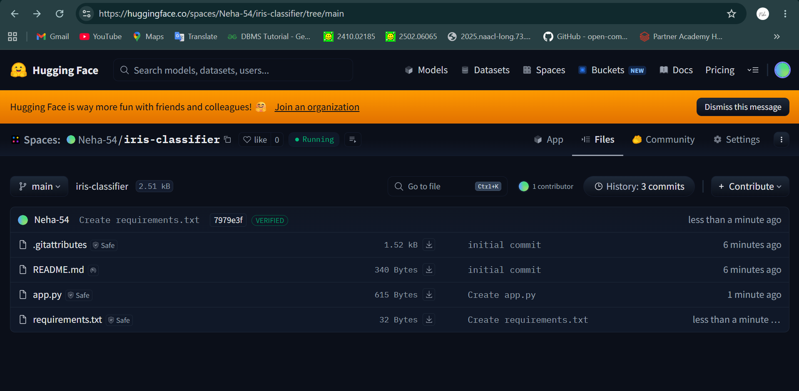

2)app.py
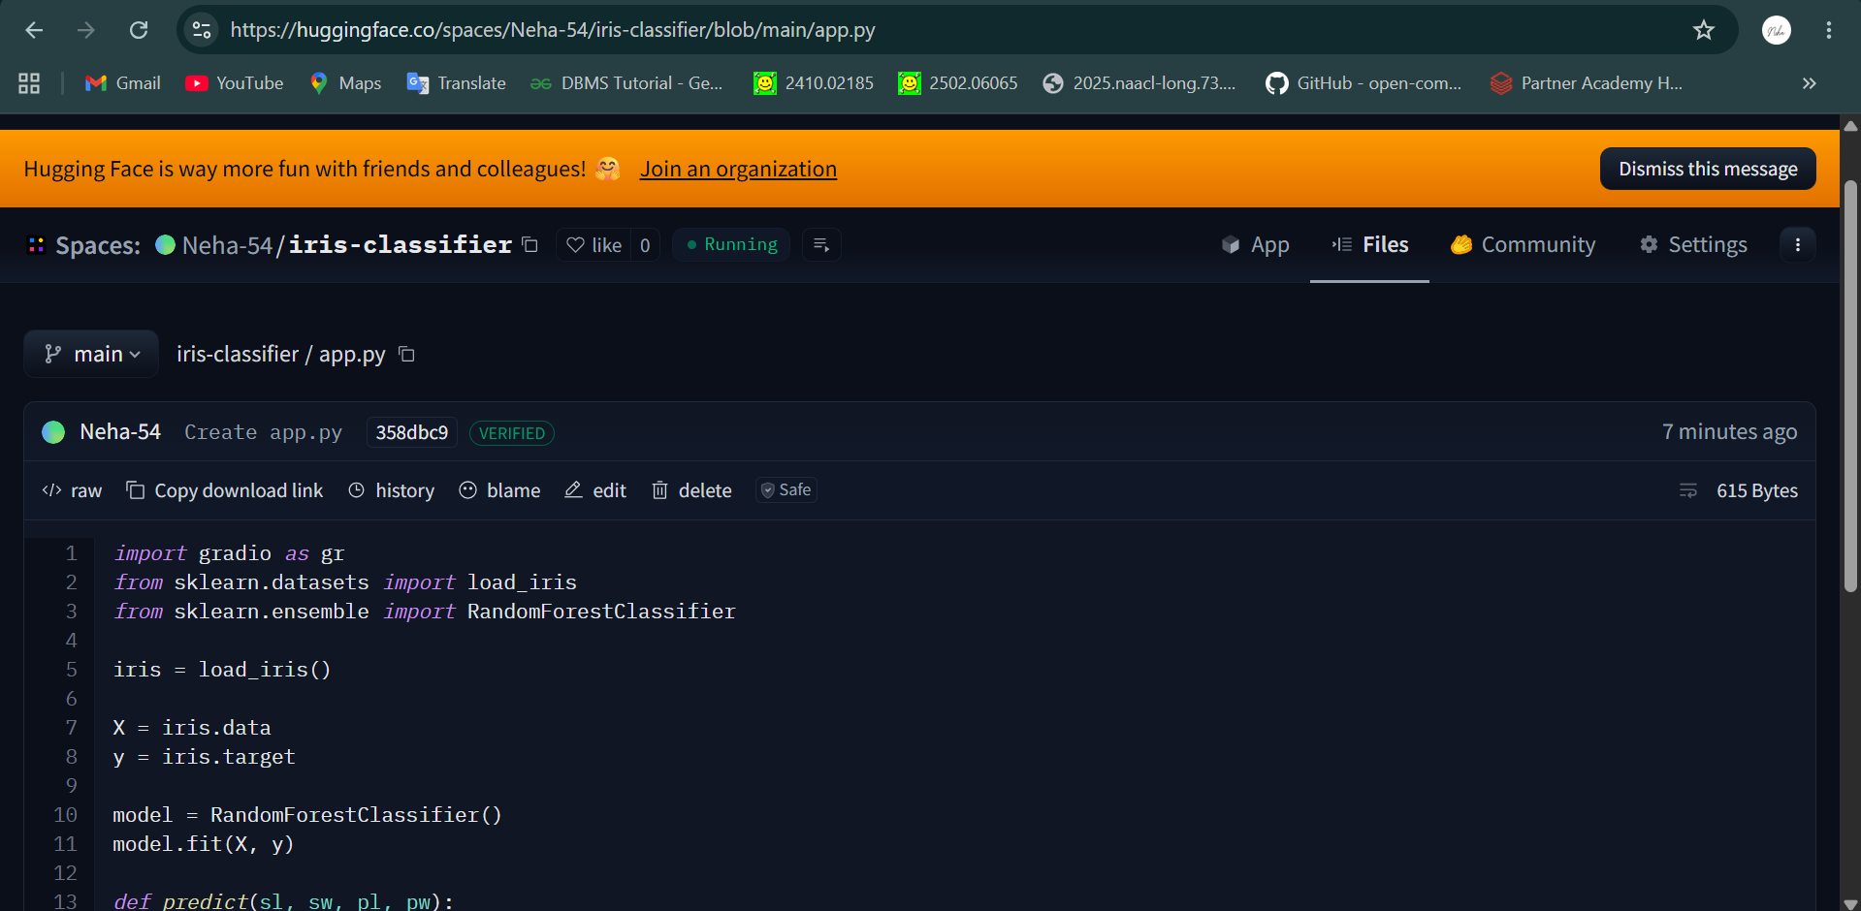

3)requirements.txt
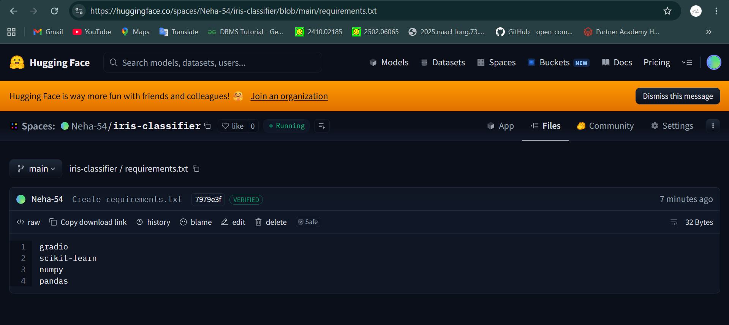

4)OUTPUT
